MKTG 4106
Clayton State University
Marketing Final Project Overview

Introduction:
The purpose of the Marketing Final Project is to demonstrate your understanding of internet marketing and applying your knowledge in a real-world setting. Utilizing SWOT (Strengths, Weaknesses, Opportunities and Threats) you will provide an understanding of the firm, identifying strategic issues and your recommendations for alternative plans of actions.
The Instructor will follow the guidelines found in Oral Presentation Skills Rubrics for grading (see below).
You will need to research a publicly traded, Fortune 500 company (instructor approval required). You will need to apply sound business strategy concepts to your evaluations and you will need to convey this information with quality writing and communication skills. This is an important research paper so please prepare accordingly.
Strategic Recommendations:
You are to recommend a corporate-level strategic decisions (e.g., terms/strategies, etc. covered in this course). This is the most important part of the presentation and thus you will be expected to support your recommendation. Be sure to incorporate terms/concepts, etc. that we have covered in this course to explain your analysis recommendation.
Due Dates:
June 6 – Company Project Form
If duplicate companies are submitted, company choices will be determined on first submission or if both are submitted at the same time, then decision will be made by random draw.
July 18 - Presentation Date – Individual or Joint oral video presentation
Submit a copy of all visual aid materials in D2L assignment. Follow guides on how to record in Teams then upload recording into the D2L assignment. The video and all supporting material must be submitted into D2L on time to be considered on time. Leaving the video in Teams does not constitute submission.
Due Date for individual/or pairs video presentations is July 18.
If joint presentations occur, the grade will be assigned per project, not per presenter.

Strategy Project
Sections: The sections of the presentation need to be appropriately covered. The video should not exceed 5 – 7 minutes. Use your time wisely. All of the following sections must be included.
- Title Page: Consists of a single cover page and should include the following: student(s) name, course name and section, and company name analyzed.
- Company Overview: Provide a description regarding the business/industry the company is participating in, and a brief history of the firm. Include such items as number of employees, gross sales, market share, etc. Paint an overall picture of the firm for those who may know nothing about the company.
- Firm’s Current Situation to include (not all inclusive)
  - SWOT Analysis Conducted
  - Brand
  - Internet Marketing Strategy
  - Value Chain
  - Business Model
  - Customer Acquisition Techniques
  - Web Performance/Effective Website
  - Social Media Utilization
  - Competitive Strategies
  - Customer Service
  - Customer Retention
- Strategic Recommendations:
  - WHY, WHY, WHY: Explain your rationale behind all decisions. Why did you select this strategy? Be sure to have your recommendations address the many problems/weaknesses you addressed earlier in the presentation (don’t just leave problems in place – attempt to correct them) AND take advantage of the opportunities and strengths of your firm.
5. References: The reference section and in-text citation method will follow APA format (for information on this style and how to handle all references/citations, please see http://owl.english.purdue.edu/owl/resource/560/01/. ) You are to properly cite throughout the work any and all information NOT found in the text.
All submissions must be in the students’ own words (no copying and pasting). Plagiarism will not be tolerated.
SWOT: What to Consider in Identifying a
Company’s Strength, Weaknesses,
Opportunities and Threats

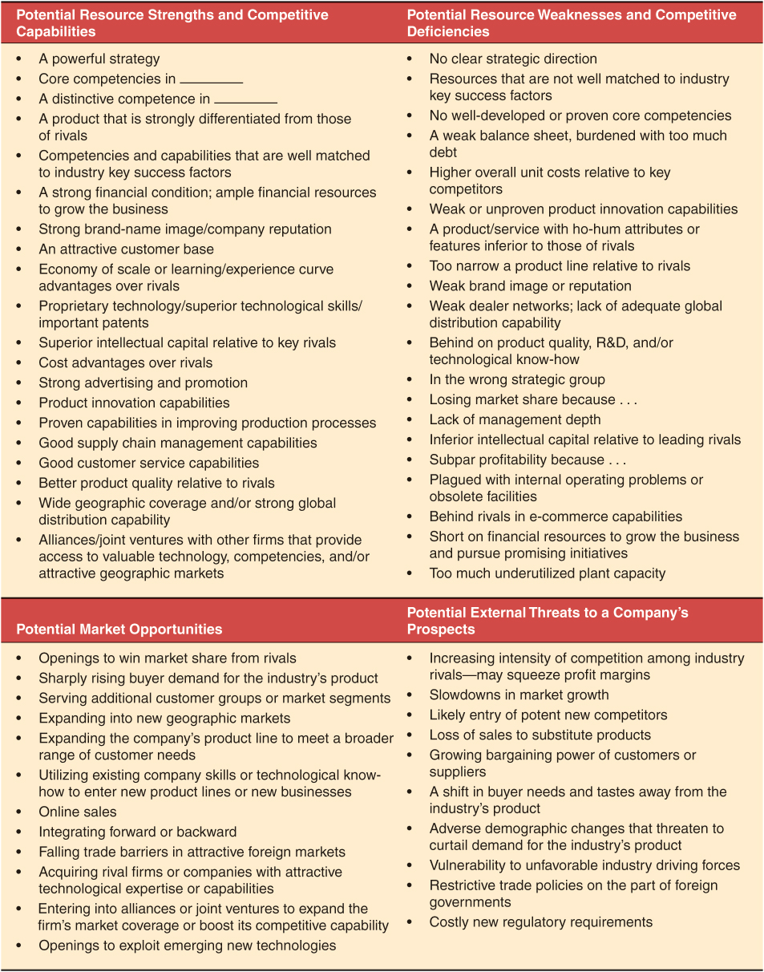
Provided by Dr. Anne Gottfried, University of Southern Mississippi

Presentation Rubric
 | Excellent  90-100 | Good  80-89 | Fair  70-79 | Poor  69 and Below | Student Score
Organization 20%  Presentation Order/Flow | 18-20 Pts  Presents information in a logical, interesting sequence which the audience can follow. | 16-17 Pts  Presents information in logical sequence which the audience can follow. | 14-15 Pts  Audience has difficulty following presentation because student jumps around. | 13 and below  Audience has difficulty following presentation because student jumps around.
Audience  20%  Persuasive techniques geared to audience. | 18-20 Pts  Marketing, product, and presentation appeal to the target audience and the audience is completely "bought over". | 16-17 Pts  Marketing, product and presentation generally appeal to target audience, but may not be strong in one or more areas of appeal. | 14-15 Pts  Marketing, product and presentation have some appeal to target audience but lacks some area of connection to target audience. | 13 and below  Marketing, product and presentation do not appeal to target audience.
Presentation Tools  20%  Use of graphics and other visual aids. | 18-20 Pts  Visual aids, graphics and/or music explain and enhance screen text, presentation, and appeal | 16-17 Pts  Visual aids, graphics and music related to text and presentation, appeal to the audience and match the task. | 14-15 Pts  Visual aids, graphics and music minimally support text and presentation. | 13 and below  Visual aids, graphics and or music are superfluous or not present at all.
Mechanics  20%  Quality of Presentation | 18-20 Pts  Presentation has no misspellings or grammatical errors. | 16-17 Pts  Presentation has no more than one misspelling and/or grammatical error. | 14-15 Pts  Presentation has two or three misspellings and/or grammatical errors. | 13 and below  Presentation has four or more spelling errors and/or grammatical errors.
Presentation Skills  20%  Language/Locution/  Eye Contact | 18-20 Pts  Students use clear voices and correct, precise pronunciation of terms so that all audience members can hear the presentation. All students maintain strong eye contact with audience. | 16-17 Pts  Students' voices are clear. Students pronounce most words correctly. Most audience members can hear presentation. Students generally make eye contact, though one or two lapses may occur. | 14-15 Pts  Students' voices are low. Students incorrectly pronounce terms. Audience members have difficulty hearing presentation. Students occasionally make eye contact. | 13 and below  Students mumble, incorrectly pronounce terms, and speak too quietly for students in the back of class to hear. Students rarely look at audience.
Total

Adapted from: https://www.rcampus.com/rubricshowc.cfm?sp=yes&code=Z3C28W&

